special.R
ganga
2022-11-20
### Special Assignment ###
#Importing the text file into R
setwd("~/Masters(GLEB)/Statistics")
library(alr4)
m1 <- read.table("nym.txt",header = TRUE)
# Regression model for the variables in the data.
pairs(Expenditure~Wealth+Pop+PInter+Density+Income+GrowthRate,data = m1)
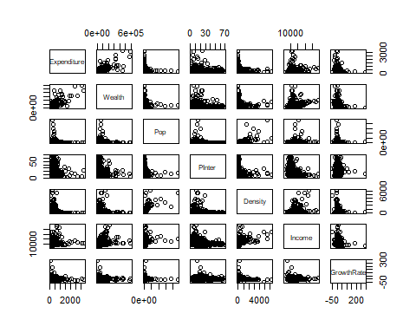
# as we know that there is no linear relation from OBS,country and state, with
# expenditures so i removed the variables and plotted.By analyzing the plot i see some
# relation with wealth,income.so, lets summarize the results
# for wealth the variance is not constant. For growth rate the plot is negatively sloped because of high leverage points on the right which is right asymmetric. If we have less sample size and with high leverage points leads to ouliers test which means we have to be careful with the analysis of that specific variable. If the sample size is high then no need to check the leverage points(maybe).
#fitting the regression model by expenditure as response
m2<-lm(Expenditure~Wealth+Pop+PInter+Density+Income+GrowthRate,data = m1)
summary(m2)
##
## Call:
## lm(formula = Expenditure ~ Wealth + Pop + PInter + Density +
## Income + GrowthRate, data = m1)
##
## Residuals:
## Min 1Q Median 3Q Max
## -1449.66 -67.11 -13.12 46.30 1437.89
##
## Coefficients:
## Estimate Std. Error t value Pr(>|t|)
## (Intercept) 2.396e+02 2.549e+01 9.399 < 2e-16 ***
## Wealth 3.879e-03 1.083e-04 35.800 < 2e-16 ***
## Pop 3.057e-05 2.881e-04 0.106 0.916
## PInter 1.780e-01 5.820e-01 0.306 0.760
## Density 7.917e-03 1.576e-02 0.502 0.616
## Income -1.107e-02 1.660e-03 -6.668 4.49e-11 ***
## GrowthRate -1.366e+00 3.274e-01 -4.173 3.29e-05 ***
## ---
## Signif. codes: 0 '***' 0.001 '**' 0.01 '*' 0.05 '.' 0.1 ' ' 1
##
## Residual standard error: 170.7 on 907 degrees of freedom
## (2 observations deleted due to missingness)
## Multiple R-squared: 0.6021, Adjusted R-squared: 0.5995
## F-statistic: 228.8 on 6 and 907 DF, p-value: < 2.2e-16
qt(1-0.05/2,907)
## [1] 1.962583
#According to the summary,
# the given t-value for the wealth,income and growthRate(36,6.6,4.2) is more than the significant level of quantile
# α=0.05 which is 1.96.so these regressors are statistically significant also the p-values of these regressors are
# nearly zero.The given data provides evidence against the null hypothesis. so, we reject the null hypothesis
# which states that there is some effect between expenditure and predictors- wealth,income and growthRate.
# for prediction definitely we have to analyse using the residual plots its is the basic.first we have to do the residual test before analysing the summary.
residualPlots(m2, smooth=T)
FTest- if the two variables are correlated we see the significance of the two
To see the relation of standard error because we cant analyse this relation by using the t test.
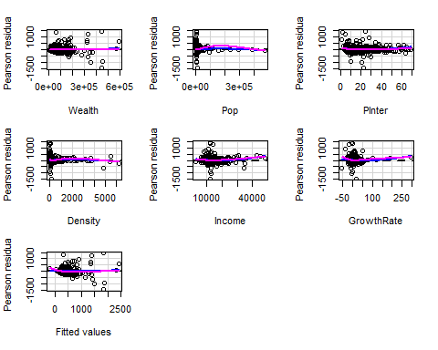
## Test stat Pr(>|Test stat|)
## Wealth 0.6940 0.487850
## Pop -1.1320 0.257936
## PInter 4.1351 3.878e-05 ***
## Density -1.5723 0.116230
## Income 3.9914 7.100e-05 ***
## GrowthRate 2.8460 0.004527 **
## Tukey test 1.0944 0.273775
## ---
## Signif. codes: 0 '***' 0.001 '**' 0.01 '*' 0.05 '.' 0.1 ' ' 1
#the higher the sample size the more significance between the variables.
So, the strategies we have
(1) Power Transformation( if there is asymmetry there we can do the transformation we analyze it by watching the residual plot)( if we have the negative length variable remember to compute the min value and add the min value to the variable. Eg:-growthRate+55)
(2) add quadratic function( we see some significance in the residual analysis
of the quadratic function)
(3) add interaction (or) additional complexity
(4) use the combination of parametric /non-parametric regression.
(5) do nothing.
# By analyzing the residual plots i see that the residuals for wealth, population,density are nearly
# zero but we are interested in the fitted (tukey test) of residuals where the p value is 0.46
# which is not significant. so, there is no evidence to reject the null hypothesis. According to our
# assumption our fitted model has less residual values. Which helps us to predict the model for the
# years 2005 and 2025.
#even if I have a null plot we maybe have some relationship. So we don’t do the transformation before we first check the residual plots. if I have a quadratic plots in visualization it shows me there is no relation between regressors but actually there is.
# By using the table from the question i predict the fitted expenditure for the given years
# FITTED VALUES CONFIDENCE INTERVAL (CONFIDENCE INTERVAL FOR A CONDITIONAL MEAN) -- Warwick 2005
predict(m2, newdata=data.frame(Pop=c(20442), Wealth=c(85000),PInter=c(24.7),Density=c(214), Income=c(19500), GrowthRate=c(35)), interval="confidence", level=0.95)
## fit lwr upr
## 1 312.2412 279.7093 344.773
# SINGLE VALUE CONFIDENCE INTERVAL -- Warwick 2005
predict(m2, newdata=data.frame(Pop=c(20442), Wealth=c(85000),PInter=c(24.7),Density=c(214), Income=c(19500), GrowthRate=c(35)),interval="prediction", level=0.95)
## fit lwr upr
## 1 312.2412 -24.28736 648.7697
# FITTED VALUES CONFIDENCE INTERVAL (CONFIDENCE INTERVAL FOR A CONDITIONAL MEAN) -- Warwick 2025
predict(m2, newdata=data.frame(Pop=c(31033), Wealth=c(89000),PInter=c(26),Density=c(325), Income=c(20000), GrowthRate=c(40)), interval="confidence", level=0.95)
## fit lwr upr
## 1 316.8208 280.1543 353.4873
# SINGLE VALUE CONFIDENCE INTERVAL -- Warwick 2025
predict(m2, newdata=data.frame(Pop=c(31033), Wealth=c(89000),PInter=c(26),Density=c(325), Income=c(20000), GrowthRate=c(40)), interval="prediction", level=0.95)
## fit lwr upr
## 1 316.8208 -20.13254 653.7741
############
# FITTED VALUES CONFIDENCE INTERVAL (CONFIDENCE INTERVAL FOR A CONDITIONAL MEAN) -- Manroe 2005
predict(m2, newdata=data.frame(Pop=c(10496), Wealth=c(58000),PInter=c(8.8),Density=c(695), Income=c(17100), GrowthRate=c(35)), interval="confidence", level=0.95)
## fit lwr upr
## 1 234.767 207.3638 262.1703
# SINGLE VALUE CONFIDENCE INTERVAL -- Manroe 2005
predict(m2, newdata=data.frame(Pop=c(10496), Wealth=c(58000),PInter=c(8.8),Density=c(695), Income=c(17100), GrowthRate=c(35)), interval="prediction", level=0.95)
## fit lwr upr
## 1 234.767 -101.3045 570.8385
# FITTED VALUES CONFIDENCE INTERVAL (CONFIDENCE INTERVAL FOR A CONDITIONAL MEAN) -- Manroe 2025
predict(m2, newdata=data.frame(Pop=c(13913), Wealth=c(60000),PInter=c(10.1),Density=c(959), Income=c(18100), GrowthRate=c(35)), interval="confidence", level=0.95)
## fit lwr upr
## 1 233.8774 203.2047 264.5502
# SINGLE VALUE CONFIDENCE INTERVAL -- Manroe 2025
predict(m2, newdata=data.frame(Pop=c(13913), Wealth=c(60000),PInter=c(10.1),Density=c(959), Income=c(18100), GrowthRate=c(35)), interval="prediction", level=0.95)
## fit lwr upr
## 1 233.8774 -102.4764 570.2313
############
# FITTED VALUES CONFIDENCE INTERVAL (CONFIDENCE INTERVAL FOR A CONDITIONAL MEAN) -- Tuxedo 2005
predict(m2, newdata=data.frame(Pop=c(10685), Wealth=c(116000),PInter=c(6.1),Density=c(249), Income=c(28300), GrowthRate=c(300)), interval="confidence", level=0.95)
## fit lwr upr
## 1 -30.41357 -225.3316 164.5044
# SINGLE VALUE CONFIDENCE INTERVAL -- Tuxedo 2005
predict(m2, newdata=data.frame(Pop=c(10685), Wealth=c(116000),PInter=c(6.1),Density=c(249), Income=c(28300), GrowthRate=c(300)), interval="prediction", level=0.95)
## fit lwr upr
## 1 -30.41357 -417.9521 357.125
# FITTED VALUES CONFIDENCE INTERVAL (CONFIDENCE INTERVAL FOR A CONDITIONAL MEAN) -- Tuxedo 2025
predict(m2, newdata=data.frame(Pop=c(29246), Wealth=c(115000),PInter=c(7),Density=c(656), Income=c(25000), GrowthRate=c(100)), interval="confidence", level=0.95)
## fit lwr upr
## 1 279.4956 209.0685 349.9227
# SINGLE VALUE CONFIDENCE INTERVAL -- Tuxedo 2025
predict(m2, newdata=data.frame(Pop=c(29246), Wealth=c(115000),PInter=c(7),Density=c(656), Income=c(25000), GrowthRate=c(100)), interval="prediction", level=0.95)
## fit lwr upr
## 1 279.4956 -62.78072 621.772
FinalE <- as.table(rbind(c(351.0252, 362.8376), c(274.014, 274.8319 ), c(371.533, 409.1213)))
dimnames(FinalE) <- list(Town = c("Warwick", "Manroe", "Tuxedo"),
Expenditure = c("2005", "2025"))
# According to my prediction for constructing the new houses by the municipality has to spend the expenditure per capita
# amount in the specific years as follows:
FinalE
## Expenditure
## Town 2005 2025
## Warwick 351.0252 362.8376
## Manroe 274.0140 274.8319
## Tuxedo 371.5330 409.1213

